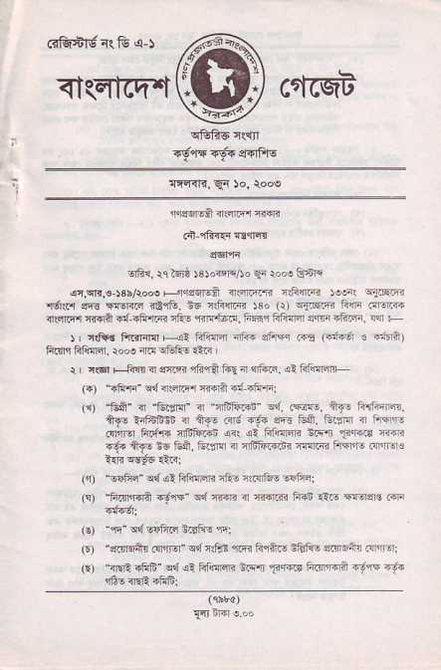
^{<tcqtcq{}ffi cufcst
_{crfu'&gi!.8} q-)
+--
rqer6|.6A <r(nlF{ RiR
.i-rfi_€{ {*fi.rt
lrfir, rq Bir, )sJ.rti{Ao F \oN R-Eri
^{q:i.!r|?.!-r3b/toN} _{F-} ^{lJqsEr} Efi _{alrmfii rrFqrri )!o(} qiiFffi rdlcr si! Trlnrr !i!tu. t6 r6llR $o _{(r)} ^{qjiEiF} F$i .r4.@ _{{sl.nr} iff{lA ^{qi} _{"firF! nft!} ^{,riF,f6.{.} Fffiltr{nl ^{erqrE} _{"Fc1n,} !4 F
_{) r} ^{qtr} d firrliln +4i Flc'lq aF{ afts{ ..Fs (4tur a oit?) ftfi Ffilrdr. rod _{{F} ^{qffis} tir I
i _{I rgl Fjid"qllq} ^{qfi€ftrm{ftn.} s: Fl{'Icn
(.) _{ffi4n"} ^{q{} 3rl4|i'r r{!ri.{-.ft.";
(c) "tr$" { _{"Erfi" ir 5EtrFiin"} ^{qa,} cirF. nT! fi""6qnfl, +F ffi6li { il R- 6.6. E 5F. Ei:rr i FF- ^{(t@ !lqa!} afu'foia i{, i. trilr ^{!q} _{T166} en r.6€ +f6 !E Eft, G.cm { a6fi.ci< Fnl.{i FrrFr! .sil.r€
^{'!rFr" q{ qI} hfi{qR rtu l:R'&6 lafri
_{:ald .-r* ed ffi} ' ]@ia -6i ,tF T€e! @
(€) "qq" c{ v!,ftq t61iE n:
(E)'sEr6i, (IrirEr" ^{qdn€E} 1.irtuft!!&liE{.fl6n .q"ror _{O'} ^{-{*} dfsli' i4 ra dffi _{srq sr'r l..n-q)} ^{q*} @
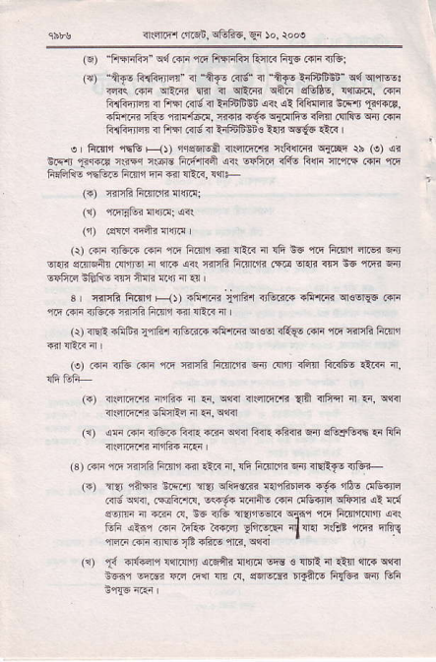
^{qa1l.6r} _{6r..rE,6ibF.,} ^{qi 50,} rod
(E) fl,nrFr" cd c{lr rF ffrqFc liqir< fitE rdr irBr
_{(a)} ^{-+f!} f{rfti@" ₄ ^{_ft.,} _{R'q 4} ^{_if.} ffiErn" _{r{} q -r&: ^{i@} _{c@} ftF _{F o} ^{qtFr qi.?} c"flE, {!@, @ li{iFircr <r filFl c{d i tlfrE$ {r( ,el filillsB _{t} ^{qri} 13f{6, ^{.frrR rtu} _{"ff{f6d,} ff{R 66 _{Farfi_6 rFF} (!rFE ^{qdr} .nr R{hqjrn! IllrJ c+6<r ?:Elinns ?B wE6 1l'cs I
e ftrn _{1$e rl))} ^{5rqs4s$} _{4$i.q-z.F rs{fi!} ^{qilqq} $ (!) .!q _{!cq!r} ^{,F,r.id} _{i$Fq ir6rg ftft.4} ^{qn} _{sFficl} ^{ql46} Fqr fi!,ri4 .1t{ rE FF€IFE rFG.6 ftql,| m €41R. !1rF
(o f{riF turrr'h llqrnl
(1) fiqtua{ra:4i
_{(jr)} (gRqrqihlr{rtt
^{(a) (!ri} !rB-i4 _{..fr} ^{q6} fi.n'i _{{ir} ^{qlR} 4 !ft _{e6} ^{'{F} _{ftnfi} ^{qnq} F} ^{q.B} _{erfiqtu.{ff6r} ir _{{rrs} ^{(rr} _{rfi'rF Fmrrd {T@} ^{q{r} _{@ E5} ^{91@} crt ccFrq i6€-s rlr ilri a.!r n E{ |
_{s I} ^{qnrfr} _{ftn1t} qt -fri.ri ^{'iqa'r} {fuim fi'Rrr creqF i}li {6..F{Jtu ffqRftfl<lll:R4
(r) ^{4Ei .A$r} _{fl&1} <tu3F _{!&'r.{r} ^{q€or} rftW .di {F {irlfi F.qn (o) .dr r]E .r|r _{{6 {i4fi ficridn} ^{qn} rqr,iJ iFtrr ffis ltrr 4.
_{e)} dlEr.r.{i niis ir {i. c{rir ffiEr,B aff _{{fr,qr n} ^{q,} cq{ ^{qr..lrlFfir} Eirqtr ir {r, clRl
(i),!F _{mi nfti." RrR"i?r} ^{qrr.rFi{.R<nEir} eftrem.{Ffi {:aft'ri nrft. {r.r I
rs ) _{c@} ^{-rq -{"ft} F.ir e r.ti {. {t Lr@ R .r?F 4'-- !!r r?n cFc4 rpr sfenrn €"iir@ ^{r-6.} _{"6,} @9@ ^{@ ce Fitfl.!} _{"q.b} ^{iFeq} _{cfi, ('fFq} ^{qto4} rt !d
svtrm _{n} ^{q.?i} .!, _{6s ?r& t{i@rR} ^{q{.q} ffi fiF$rRlrr <<1 t-- urn" ^{r ?Fa i{@} _{?irsrF c@ ++l!} ^{.?E} En"-q m@ffi!€?fcEffiq@
_{t{} d6qri !ft{r$ {rqitr {qa! sq! _{s} ^{lIIrE} 4 _{il$} ^{qrr{} c$r n6r !'@ _{@ mn {r R.} ^{qErqri{} 5rrft! F!fri llr Ffi
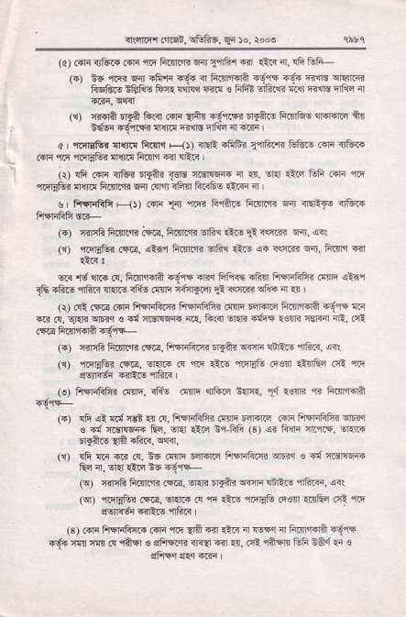
q5r5r (rrE6, ^{qfofiE,} Er )o, )ooo
(a) ..F<,tu..{|{ _{ilr ftrrtr} ^{qir} l{fr,I-ir lii<{r, rfi1@ _{l+,} F+ 1R @ rl'E !6! ? _{f'rfF+} 6ga rtu R@ 5I-.B REI@ II'IAE _{|cr{} lsie F<.c _{s} ^{rfi?} _{6ic&} ^{q{} EIE Fr q
r.r {€A Fd l.$ {@ _{{'ft} ^{{d-lE} _{rynF} is?5 dFf,at ft EfEr rdjRE {r{.! F@ nLd _{n} q?r
? ^{.nftrtu} {{d ftqn F<J) ^{ra'! ?FFi} _{lqdifii} &tuo err rJtu F .!lr ff rnitu {{ri{ ftlrn 41l {Fis
_{iil} ^{.rfi} .{lr r,tu ^{6r€i} _{r€ig} asFq-a ir .{, !]{ .Lc Ffi ..ri tq ^{q&BEr} {{r.1 Anrdr Fdr afi rE{ Fr<66 _{1t6ii} 'n
s r ft{rififr ^{F<)l Rri} _{f.ii} riqr Flft! h.{r.in 6n <'REf6 .rtu-
(.) r3EE ftTll'ln c.@, ft{lrl" Elfi.r itE _{rt} i<ri{j Fir,,4r! _{{1)} ri'llFr c.*E, {1i,1 _{ft]'ln1?} ^{qF1} 1l _{o} ^{q+} r<rF. Erit, Fm,l 4<r
@ ^{.16} {." rq, ft"'Fr? {6lq +r".r Fft6 +Rfl ftiriFF{ .ftq <t{r _{16 -fiN} ^{qfia} !l{I' 11& rIffi ^{tturrqJ} _{li iq1*} ^{qfi+} m :!r , Q) ccl.{@ .Fli ffir4i FlEliFF{ .E{E Eqrqrd ftl'r'r{A {6.'lF F .rr _{.q,} qfr ^{qnrq} _{€ 4{} ^{qdlrFir} _{!rr, frlrr} ^{qr{I?} s{ii rtstrli rer.ir nR. .ci
(o _{T{nG ft{.,n} ({F. ffi.ci 'Efti {€r $Ar! mrc, @< (q) _{ciqE&r} (EE, _{sr{.. d} ^{q&} _{iilE,r.niF} ^{('€nr} lffi.r1rrE dqF6r {iEF {l?F
_ (o) ftqriGFi .!tr]n, ilts NE 4Rir ^{n:nr,} _{d} !€nE ra fts'r.rA (.) _{!fi} ^{q?} 4d {€t 4 rq, ffiiE< .!tri Edrdrd rri SrFriliFT crI3q € Fi iGlsF{ fu. !r{ _{itrq} 'Fli (3) ^{qi} _{turi ft,r.s.} qEm ^{6qftq} _{{ff aft<,} qq3l
(r) rfr a.i .ir m. Af dire Inrwc fi4riF.4r crn<r € i{ ilorl*R &n {, sl{ _{iair} ^{ls6} rqrs-
(9 rrlrh ftT.'l" l@, -rai _{tEtu} ^{qinF} rnF.! {iam, lrr _{,a ,} ^{qrfift!.rE.} o{...! r ^{.lE} _{"6Ff.} a@ r.6? _{cm} .F c6rR6 Fft! {Fr.
(s) Rra frsFfrirr ."F fi _{1la} €r _{€i<} ^{'n} {sF"r { lii ida f6jF !q.llnr'{!(!r?n€sf'€"13a'{.E -d:'.(r:'lsnefi 64.1{r! sFl4q$<r dFd
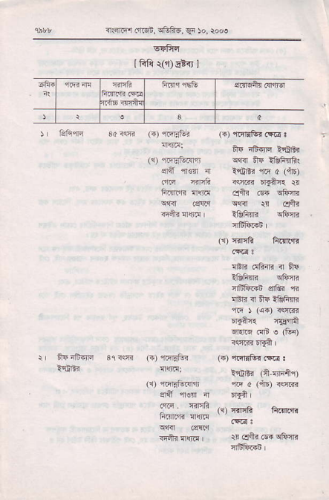
_{n.rnEr I'Eqi,} ^{qF} tu6, ^{qa} !o, :ooe
lRli r(,r) Ei<r I
r tlFF
i Erntr{rtr 3c<qa
"'ra
_{4rn} ^{q'r} _{oi|d,} ^{q&iit, qi} )o, iooe
!ffi{
!:inr
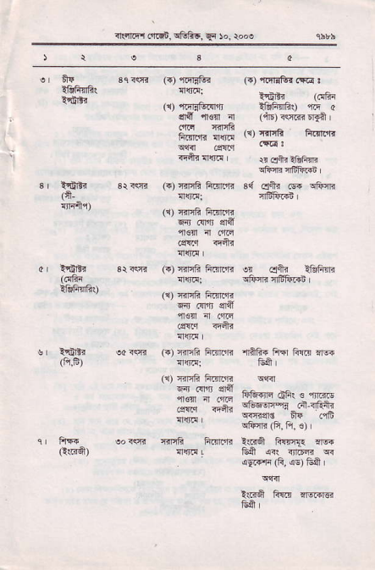
(n,
t1bfrufi$ (R,F)
Enl
Ei1
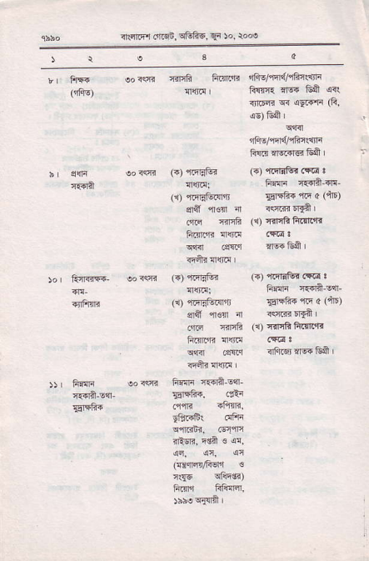
irrqliqt _{c4..i6,} q&fr6. ^{qi} !o, ro@
)t
r f1F !o<s rinfi frEnrrr ifis/rtd/qFr{$F ({is) {$1c | fisn{.466 _{GA} qr! itliE?q!!rFnG
i5) tii I
rliE/sr4c1ir$rF
' Fla'lq€RrfrA
b cqr soiqj (.) _{{qric? (o} ^{qrnrtut ({a} t a.{rft irqt!: F {F {t{]i_{!_ _{(:r)} ^{,jirEli.llir} _{8r4fr4} n r a (qF)
qiil ^{'n€n} _{"r} rq.n.r$
.{ri erh (r) {nqBftn1.Tr
ftinE llfil
^{q{<r} .sllri ffiEA I
isah !l! Ic
)o tul{{'F- oo rs _{(') r.{qer} (T) ^{,ir,l-dtud} .!@ . iifir n€dn s{-
_{TiFrrF} ({ ritEtur4rjt _{Frrft{'t5} o (nE) $ff _{rlq} 'n istrlDrrft |
.'nn {iliF (1) {.ir6ftniFri
lifirFf. !Mi!
c{'il .q{rq iii.s, ,164 Eft |
rFqi !r{ri'
)) Firir !o<R hR$i c{ila'dr
a.{]a !q- _{Fl{Fi,} .nla
_{Er'rfr{} {ctB rf!m.
_{dffii.} 6fir
^{q9llarEj,} aq'tln
ituR, rdA _{s} q!
(Efn/1?sri €
₁₁₁₆ qftd?)
ftfi frf!{!r'
riho eflil I
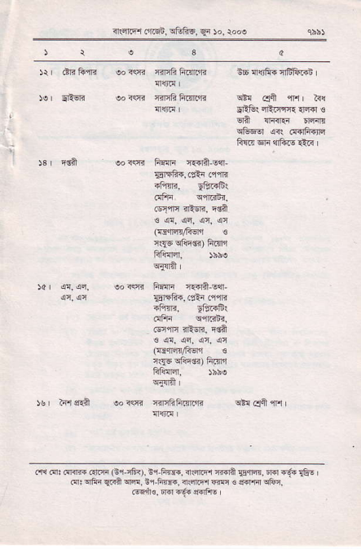
^{rn} ftqr ..I!qn. siiF6, qi )o. rdoo
_{eos(fr fir$i} q.{lit-Eqr
EcF{,(':r .1{r
4Fm, yiffir
_{ofii} q{'.i;i.
c{iq ?E:$r, ru?
€ql'!{c.qiiqc
({i.ic{ficrI €
_{iqe} ^{q1iffr)} ftfll
eoffi F:$r r.{A,sqr
srr6i,.rA .q{i
^{-Fm,} Flffir
_{.!Fri} qqr.3nr,
_{.€nfr rFqR,} q6
_{FrqtanGEu} €
_{rsE} ^{q8r6.)} ftlni
Fl!{Er,
oo r(f{ :rjF6ftfl.'r3 ^{qt!} cdl $il I
_{.,rl o:} ^{(ffi ({R} _{Gii6!.} fi-Fm. ^{netFl4daEffi, n.]"g.} €E, _{d:} ^{qF{} _{CRal} cR, ^{tr,F} r{,?clsrrffi€ffi!6n.
^{@qfi€. m} _{"6.} {.FrE

